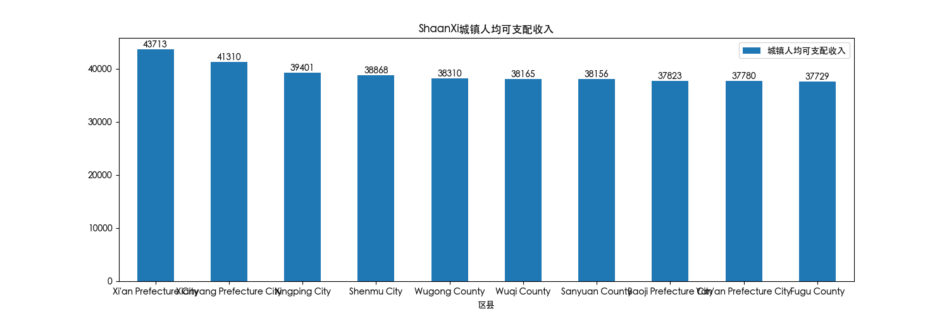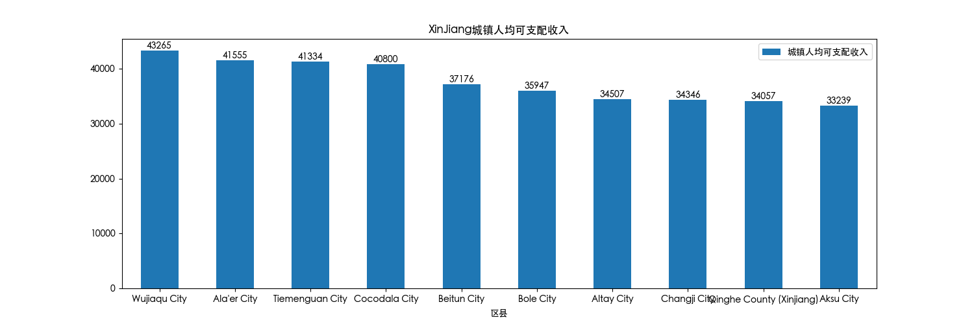

广东，江苏的top1城镇人均可支配收入超过7万；浙江超过8万。其他省大部分在4万左右。从top10来看，浙江和江苏收入平均最高，第三名是广东。